**Studio Workshops**

*Request a workshop by contacting Fallon Allison at fallon.allison@icc.edu. Please request workshops with at least 2 weeks advance notice. Please provide the number of students in the class and indicate if the classroom is a computer lab.*

**Invention: Getting Started**

Begins by examining a writing prompt and providing students with strategies for planning their writing process. Assists students with brainstorming aspects of the writing process, during which writers discover ideas and learn how to sharpen the focus of their essays.

**Documentation Styles and Strategies**

Addresses MLA, APA, or CMS documentation strategies. This popular workshop begins with a brief discussion of intellectual property (why we document sources) and conventions (how we document sources). The workshop then focuses on the particular style the course uses, covering both the in-text citation and bibliography formats. Geared toward the most popular types of sources, this workshop works best when students have already completed some research.

**Using Sources Effectively**

Examines writing at the paragraph level. This workshop guides students in how to use sources to support their ideas, how to recognize the proper balance of ideas, explanations, and evidence, and how to incorporate paraphrases and quotations. Students will collaborate to craft paragraphs that use sources to support their ideas.

**Revision**

Assists students with the revision of a paper they have already drafted, focusing on large-scale concerns like analysis, structure, and organization. We work through three revision activities.  First, students complete a brief exercise in which they rearticulate the main claims of their papers.  Following this is an exercise designed to identify organizational problems. For the third activity, students may choose one of four exercises allowing them to focus on their specific needs.

**Thesis Statements**

Focuses on understanding the characteristics of a strong thesis and how to write one. Using a prompt from the class, students will begin drafting their own thesis statements. A discussion of how to argue for a thesis rounds out the workshop.

**Learning Styles**

Introduces students to the concept of learning styles. Students will participate in a series of activities that challenge them to identify which learning styles work best for them. Finally, the workshop will focus on strategies for tailoring classroom and study behavior to each learning style in order to maximize results.

**Organizing a Paper: Finding Purpose in Ideas**

Focuses on different techniques for organizing papers as well as discovering purpose through organization. Students participate in an organization activity as a group, and then they choose from a list of four other activities. This workshop works best when presented after the student has done some research.

**Selecting and Narrowing Your Topic**

This workshop focuses on ways to narrow broad subjects into manageable and meaningful paper topics.

**Facts vs. Opinions**

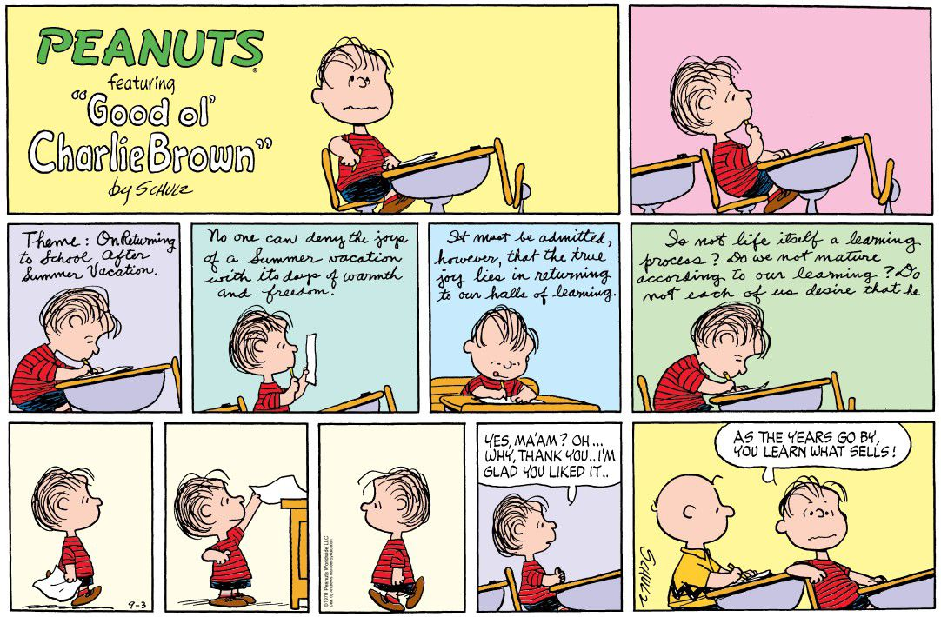Focuses on illustrating the difference between facts and opinions, especially as they relate to support in argumentative essays. Students work in groups to support different sides of an argument using fact-based support.